The Word of God was made flesh

Society of Christian Doctrine


44th Year 2008

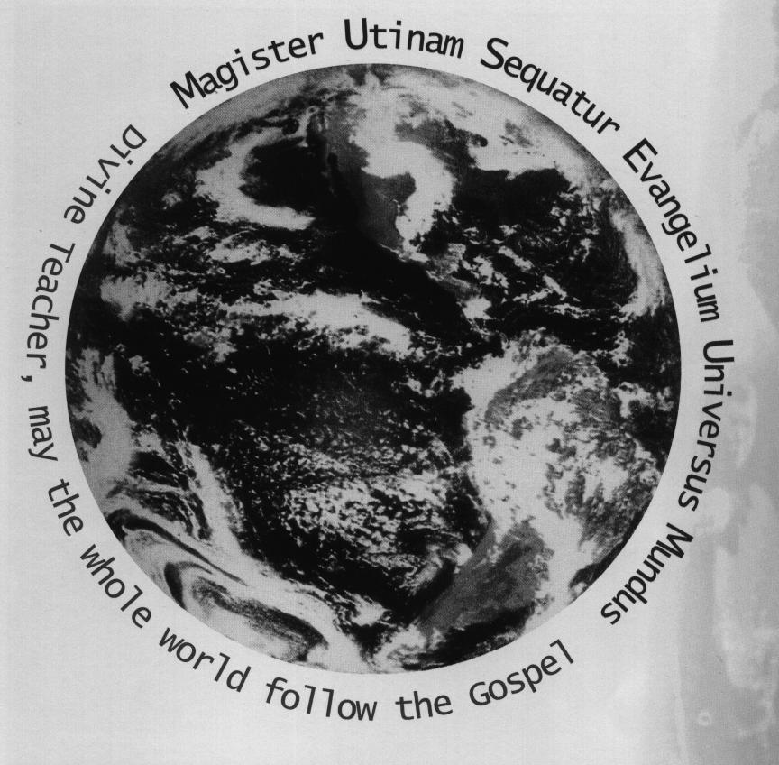

Assignment

Programme

October - November - December

2026

CONTENTS

SYLLABUS SUGGESTED TIMELINE 2
2008 SYLLABUS AT A GLANCE 3

TALKS 4
SPECIAL PROTECTORS 4
WATCH LITANY INTENTIONS 4
SPECIAL PROGRAMMES 4
COMMEMORATIONS 4

THOUGHT OF THE MONTH 5

NOTES 5

y all that

The Word of God was made flesh

PRECA COMMUNITY
(Society of Christian Doctrine)

62nd Year 2026

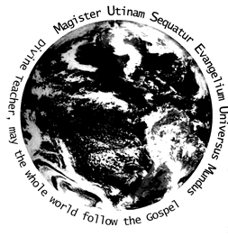

For the 2026 Week of Prayer for Christian Unity, Pope Leo XIV emphasized the theme, “There is one body and one Spirit, just as you were called to the one hope of your calling” (Ephesians 4:4), calling for visible unity. Under his motto In Illo uno unum ("In the One, we are one"), he stresses that this unity is a divine imperative, not just an ideal, bridging diverse traditions in Christ.
Key aspects of Pope Leo XIV's focus on this theme include:
- Source of Theme: The theme is taken from St. Paul's Letter to the Ephesians and was used for the Week of Prayer for Christian Unity (January 18-25, 2026).
- Vision for Unity: Pope Leo XIV argues that Christian unity is a "gift from on high" rather than just human effort, encouraging churches to move beyond internal divisions.
- Episcopal Motto: His motto, In Illo uno unum, is rooted in St. Augustine's teaching that although Christians are many, they are one in Christ.
- Ecumenical Action: The Pope emphasized this message during ecumenical vespers, highlighting the need for "a communion which does not imply absorption or domination, but rather an exchange of the gifts".
- Context: The 2026 materials were prepared in collaboration with the Armenian Apostolic Church, with the Pope highlighting the Armenian Christian witness and encouraging dialogue in the face of suffering.

CONTENTS

CONTENTS

SYLLABUS 4
TALKS 5
SPECIAL PROTECTORS 5
WATCH LITANY INTENTIONS 5
SPECIAL PROGRAMMES 5
COMMEMORATIONS 5

THOUGHT OF THE MONTH 5

GENERAL NOTES 6

ANNIVERSARIES 6
WEEKLY ASSIGNMENT 6
PROGRAMME FOR THE MONTH OF OCTOBER 7

PROGRAMME FOR THE MONTH OF NOVEMBER 8
PROGRAMME FOR THE MONTH OF DECEMBER 9
NO PROGRAMME FOR THE MONTH OF JANUARY 2027 (Left to the discretion of the Superior) --
BIOGRAPHY OF ST. FAUSTINA KOWALSKA (October 5th) 10-12
BIOGRAPHY OF ST. TERESA OF AVILA (October 15th) 13-14
BIOGRAPHY OF ST. CHARLES BORROMEO (November 4th) 15-16
BIOGRAPHY OF ST. CATHERINE OF ALEXANDRIA (November 25th) 17-18
BIOGRAPHY OF ST. JOHN OF THE CROSS (December 14th) 19-20

BIBLE SHARING NO. 31 (Matthew 16:13-20) (Friday October 2nd) 21
BIBLE SHARING NO. 223 (1 Corinthians 4:1-21) (Friday October 9th) 22
BIBLE SHARING NO. 390 (Acts 10:24-48) (Friday October 16th) 23
BIBLE SHARING NO. 450 (Judges 16:1-31) (Friday October 23rd) 24
BIBLE SHARING NO. 32 (Matthew 16:21-28) (Friday November 6th) 25
BIBLE SHARING NO. 224 (1 Corinthians 5:1-13) (Friday November 13th) 26
BIBLE SHARING NO. 391 (Acts 11:1-18) (Friday November 20th) 27
BIBLE SHARING NO. 33 (Matthew 17:14-22) (Friday December 04th ) 28
BIBLE SHARING NO. 225 (1 Corinthians 6:1-20) (Friday December 11th) 29
BIBLE SHARING NO. 79 (Luke 2:1-20) (Friday December 18th) 30

SPIRITUAL EXAMINE CHAPTERS FOR:

OCTOBER – Obedience; NOVEMBER – Poverty; DECEMBER – Faith

SYLLABUS
October – November – December 2026

IMPORTANT DOCUMENTS & PROCEDURES
October - December On the 7th, 17th and 27th 0f the month, any of the following should be studied: 1. Rule of Life
2. For the Seed to bear Fruit
3. The Dimensions of an SDC Centre
4. Urgings of the Heart
5. Right Intention Seeking God’s Glory.

October - December Prayer and Liturgy
The General Instruction of the Roman Missal
The Structure of the Mass, Its Elements and its Parts (72 - 76)

October - December Dogmatic Studies

Mary’s Immaculate Conception and Purgatory in November.

October - December Moral Studies
Christ’s Institution of the Sacraments and Their Efficacy to impart Grace.

October - December Spirituality
Love of God and Neighbour

October - December Voice of the Beloved
The Parables of Jesus: (1) Wedding Feast (Matthew 22:1-14);
(Luke 14:16-24); (2) Ten Virgins (Matthew 25:1-14);
(3) The Talents (Matthew 21:14-30); Luke 19:11-27)

October - December Apostolic Studies (The Letters of the Apostles)

Letters of St Peter 1 and 2

October - December Church History
Vatican 2 and summary of the Documents produced.

October - December Old Testament Studies
The Book of Proverbs or Book of Choice

October - December From the Encyclicals and other Church Documents
Magnifica Humanitas: On Safeguarding the Human Person in the Time of Artificial Intelligence

October - December From the Founders Writings
Any writings from the Founder.

SPIRITUAL EXAMINE CHAPTERS FOR:

OCTOBER – Obedience ; NOVEMBER –Poverty; DECEMBER – Faith

THE DIVINE ATTRIBUTES
(Refer: The Watch pgs. 94-98)

Monday – Eternity | Tuesday - Immensity | Wednesday – Immutability
Thursday – Wisdom | Friday – Justice | Saturday – Mercy

Sunday - Omnipotence

Talks

October 04th The Most Holy Rosary
November 08th The Church’s Teaching on Purgatory
December 06th The Immaculate Conception
December 26th St Stephen, First Martyr

Special Protectors

The Month of October Jesuit Saints
The Month of November All Saints
The Month of December Holy Innocents

Watch Litany Intentions

The Month of October That all members shun Pride
The Month of November Divine Protection of our Society
The Month of December More Labourers into the Vineyard

Special Programmes

October 04th The Most Holy Rosary
December 08th The Immaculate Conception
December 25th Christmas Day Program
December 26th St Stephen, the First Martyr

Commemorations

October 05th St. Faustina Kowalska
October 15th St. Teresa of Avila
November 04th St. Charles Borromeo
November 25th St. Catherine of Alexandra
December 18th St. John of the Cross

Thought of the Month

The Month of October Humiliations Precede Glory
The Month of November To Practice Virtue in a Secular World
The Month of December Let Christ be our Model

General Notes

1. October 26th, November 24th and, December 24th
(Please refer to exercise on page 100 in the members Watch)
2. November 01st Mass and Holy Communion to be offered for all Benefactors
3. November 03rd Melbourne Cup Day (No Assignment – Melbourne Centres Only)
4. November 04th Mass and Holy Communion to be offered for all Deceased
Members and Parents of members. (Melbourne Members)
5. November 21st The Presentation of Mary (15 Decades)
6. December 08th The Immaculate Conception (15 Decades)
7. Please note, that during the month of November, it is customary that each centre
visit a cemetery and pray for the souls in Purgatory. If young people are present, please ensure that a short talk and explanation is given.
8. During the Sundays of Advent (4 Sundays), the Spiritual Examine from the members
Watch page 125 is read.
9. The Novena (School of Bethlehem) in preparation for Christmas commences on Tuesday 15th December and finishes on Wednesday December 23rd.

Anniversaries
1. October 22nd Kevin P. Wood (Tasmania) (22/10/1964)
2. October 16th Emanuel Baldacchino (Queensland) (16/10/2008
3. November 4th Michael Rifello (Melbourne) (04/11/1996)
4. November 28th Charles Puli (Melbourne) (28/11/1999)
5. December 22nd George Puli (Melbourne) (22/12/1995)
6. January 11th Oscar Sciberras (Ex Melb ) (11/01/1991)
7. January 15th Sunny Falzon (Adelaide) (15/01/2005)
8. January 17th Lora Meli (Sydney) (17/01/1989)
9. January 21st Charles Manicolo (Melbourne) (21/01/2003)

Weekly Assignment Subjects

(Suggested only)

Monday:- Dogmatic Studies (D.S.) and Voice of the Beloved (V.B.)
Tuesday:- Spiritual Formation S.F.) and Apostolic Studies (A.S.)
Wednesday:- Pedagogy
Thursday:- Moral Studies (M.S.) and Old Testament (O.T.)
Friday:- Church History (C.H.)
Saturday:- Pedagogy, Prayer and Liturgy
Sunday:- (am) Bible Sharing and (pm) Union.

Programme for the Month of
OCTOBER - 2026
Thought of the Month: Humiliations Precede Glory
Watch Litany Intentions: That all Members Shun Pride

ASSIGNMENT ITEM | DESCRIPTION | DATE (*)
LITURGIES | Our Lady of the Most Holy Rosary | Saturday 04th
TALKS | On the Holy Rosary | 04th
SPIRITUAL EXAMINE TOPIC | Obedience | (**)
COMMEMORATIONS | St Faustina Kowalska  St Teresa of Avila | 05th  15th
CANON LAW | Canons: 840 – 844 (1 & 2) | (**)
SPIRITUAL DIRECTORY | Directives 255 - 261 | (**)
FROM THE FOUNDER’S WRITINGS | Discipleship: Topic 17: A - D | (**)
UNION READINGS | Theme: The Acceptance of God’s Will  Epistle: - James 1:1-12  Gospel: - Mark 3:31-35  Great Book: Page 17  Theme: Prayer  Epistle: - 1 Thessalonians 5:12-18  Gospel: - Luke 11:1-13  Great Book: Page 18  Theme: Silence  Epistle: - James 3:1-12  Gospel: - Matthew 5:33-37  Great Book: Page 19 | Sunday 11th  Sunday 18th  Sunday 25th
BIBLE SHARING | No. 31 (Matthew 16:13-20)  No. 223 (1 Corinthians 4:1-21)  No. 390 (Acts 10:24-48)  No. 450 (Judges 16:1-31) | Friday 02nd  Friday 09th  Friday 16th  Friday 23rd
CHORAL WATCH | NIL THIS MONTH
ANNIVERSARIES | Emanuel Baldacchino – Qld. (16/10/2008)  Kevin P. Wood – Tasmania (22/10/1964) | 16th  22nd

(*) Date shown is only recommended. This item may be done anytime during the month
(**) indicates can be done anytime during the month.

Programme for the Month of
NOVEMBER – 2026
Thought of the Month: To Practice Virtue in a Secular World
Watch Litany Intentions: Divine Protection of our Society

ASSIGNMENT ITEM | DESCRIPTION | DATE (*)
LITURGIES | NIL THIS MONTH
TALKS | The Church’s Teaching on Purgatory | 06th
SPIRITUAL EXAMINE TOPIC | Poverty | (**)
COMMEMORATIONS | St. Charles Borromeo  St. Catherine of Alexandra | 04th  25th
CANON LAW | Canons: 844 (3, 4, 5,)- 849 | (**)
SPIRITUAL DIRECTORY | Directives 262 - 267 | (**)
FROM THE FOUNDER’S WRITINGS | Discipleship: Topic 17: E - H | (**)
UNION READINGS | Theme: Contempt for the world  Epistle: - 1 John 2:12-17  Gospel: - Luke 14:25-33  Great Book: Page 21  Theme: The insidiousness of our Spiritual Enemies  Epistle: - James 1:1:13-8  Gospel: - Luke 11:14-26  Great Book: Page 22 | Sunday 15th  Sunday 22nd
BIBLE SHARING | No. 32 (Matthew 16:21-28)  No. 224 (1 Corinthians 5:1-13)  No. 391 (Acts 11:1-18) | Friday 06th  Friday 13th  Friday 20th
CHORAL WATCH | Saturday Episodes  Eloquia (15-20 min); Choral Watch –  Part 1 - (6.00am-12.00 noon)  (pm) Part 2 (2.00pm-7.00pm) to include Episodes from St Elijah | Saturday 28th  Sunday 29th
ANNIVERSARIES | Michael Rifello – Melb. (4/11/1996)  Charles Puli – Melb. (28/11/1999) | 4th  28th

(*) Date shown is only recommended. This item may be done anytime during the month
(**) indicates can be done anytime during the month.
Note: for the regular subject matters, the local superior may choose the day and allocated time during the month.

Programme for the Month of
DECEMBER – 2026
Thought of the Month: Let Christ be our Model
Watch Litany Intentions: More Labourers into the Vineyard
ASSIGNMENT ITEM | DESCRIPTION | DATE (*)
LITURGIES | *Immaculate Conception  *Christmas Day  *St Stephen-First Martyr | 08th  25th  26th
In Preparation for Christmas, please conduct the following Novena from the School of Bethlehem during the Assignment.
  Day 1 Page 1 | Tuesday 15th
  Day 2 Page 2 | Wednesday 16th
  Day 3 Page 3 | Thursday 17th
  Day 4 Page 4 | Friday 18th
  Day 5 Pages 5 & 6 | Saturday 19th
  Day 6 Pages 7 & 8 | Sunday 20th
  Day 7 Pages 9 & 10 | Monday 21st
  Day 8 Pages 11 & 12 | Tuesday 22nd
  Day 9 Pages 13 & 14 | Wednesday 23rd
TALKS | Immaculate Conception  Saint Stephen – First Martyr | 08th  26th
SPIRITUAL EXAMINE TOPIC | The Virtue of Poverty | (**)
COMMEMORATIONS | St John of the Cross | 14th
CANON LAW | Canons: 850-860 | (**)
SPIRITUAL DIRECTORY | Directives268 - 273 | (**)
FROM THE FOUNDER’S WRITINGS | Discipleship: Topic 18 A-D) | (**)
UNION READINGS | Theme: Love of God  Epistle: - 1 John 4:7-21  Gospel: - Mark 12:28-34  Great Book: Page 23  Theme: Love of Neighbour  Epistle: - 1 Corinthians 13:1-8  Gospel: - Luke 10:25-37  Great Book: Page 24 | Sunday 13th  Sunday 20th
BIBLE SHARING | No. 33 (Matthew 17:14-22)  No. 225 (1 Corinthians 6:1-20)  No. 79 (Luke 2:1-20) | Friday 04th  Friday 11th  Friday 18th
CHORAL WATCH | NIL THIS MONTH
ANNIVERSARIES | Victor Delicata – (Malta) (02-12-2012)  George Puli – (Melb) (22-12-1995)  Oscar Sciberras – (Malta) (11/01/1991)  Sunny Falzon (Adelaide) (15/01/2005)  Lora Meli (Sydney) (17/01/1989)  Charles Manicolo (Melbourne) (21/01/2003) | 02nd  22nd  11th  15th  17th  21st

SAINT FAUSTINA KOWALSKA
(1905 - 1938)
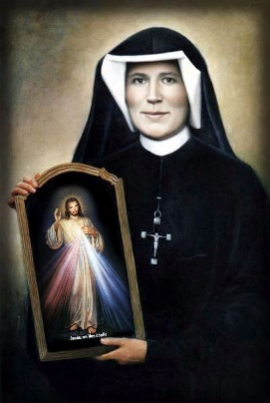
Saint Maria Faustina Kowalska of the Blessed Sacrament was born as Helena Kowalska, in Poland on August 25, 1905. She was the third of 10 children to a poor and religious family.
Faustina first felt a calling to the religious life when she was just seven years old and attended the Exposition of the Blessed Sacrament. After finishing her schooling, Faustina wanted to immediately join a convent. However, her parents refused to let her.
Instead, at 16-years-old, Faustina became a housekeeper to help her parents and support herself.
In 1924, Faustina experienced her first vision of Jesus. While at a dance with her sister, Natalia, Faustina saw a suffering Jesus and then went to a Cathedral. According to Faustina, Jesus instructed her to leave for Warsaw immediately and join a convent.
Faustina packed her bags at once and departed the following morning. When she arrived in Warsaw, she entered Saint James Church in Warsaw, the first church she came across, and attended Mass.
While in Warsaw, Faustina approached many different convents, but was turned away every time. She was judged on her appearances and sometimes rejected for poverty.
Finally, the mother superior for the Congregation of the Sisters of Our Lady of Mercy decided to take in Faustina on the condition that she could pay for her own religious habit. Working as a housekeeper, Faustina began to save her money and make deposits to the Convent.

On April 30, 1926, at 20-years-old, she finally received her habit and took the religious name of Sister Maria Faustina of the Blessed Sacrament and in 1928, she took her first religious vows as a nun.
Over the next year, Faustina travelled convents as a cook. In May 1930 she arrived in Plock, Poland. Soon after, she began to show the first signs of her illness and was sent away to rest. Several months later, Faustina returned to the convent.
On February 22, 1931, Faustina was visited by Jesus, who presented himself as the "King of Divine Mercy" wearing a white garment with red and pale rays coming from his heart. She was asked to become the apostle and secretary of God's mercy, a model of how to be merciful to others, and an instrument for reemphasizing God's plan of mercy for the world.
In her diary, Faustina writes:
"In the evening, when I was in my cell, I became aware of the Lord Jesus clothed in a white garment. One hand was raised in blessing, the other was touching the garment at the breast. From the opening of the garment at the breast there came forth two large rays, one red and the other pale. In silence I gazed intently at the Lord; my soul was overwhelmed with fear, but also with great joy. After a while Jesus said to me, 'paint an image according to the pattern you see, with the inscription: Jesus, I trust in You.'"
Faustina also describes during that same message, Jesus explained he wanted the Divine Mercy image to be "solemnly blessed on the first Sunday after Easter; that Sunday is to be the Feast of Mercy."
Faustina, not knowing how to paint, asked around her Plock convent for help but was denied. It wasn't until three years later, in 1934, that the first painting of the image was created by Eugene Kazimierowski.
In 1932, Faustina returned to Warsaw. On May 1, 1933, she took her final vows in Lagiewniki and became a perpetual sister of Our Lady of Mercy.
After taking her vows, Faustina was transferred to Vilnius, where she met Father Michael Sopocko, the appointed confessor to the nuns. During her first confession with Sopocko, Faustina told him about her conversations with Jesus and his plan for her. Father Sopocko insisted she be evaluated by a psychiatrist. Faustina passed all the required tests and was determined sane, leading Sopocko to support her religious efforts.

Sopocko encouraged her to start keeping a diary and to record all of her conversations with Jesus. Faustina told Sopocko about the Divine Mercy image and it was Sopocko who introduced her to Kazimierowski, the artist of the first Divine Mercy painting.
According to Faustina's diary, on Good Friday, April 19, 1935, Jesus told her he wanted the Divine Mercy image publically homered. On April 26, 1935, Father Sopocko delivered the very first sermon on the Divine Mercy.
In September 1935, Faustina wrote about her vision of the Chaplet of Divine Mercy, used to obtain mercy, trust in Christ's mercy and to show mercy to others.
During the following year, Faustina attempted to set up a new congregation for Divine Mercy, but was reminded that she was perpetually vowed to her current order and sent back to Warsaw. She reported Jesus said to her, "My Daughter, do whatever is within your power to spread devotion to My Divine Mercy, I will make up for what you lack."
In 1936, Faustina fell ill again. She moved to the sanatorium in Pradnik, Krakow and continued to spend most of her time in prayer.
In July 1937, the first holy cards with the Divine Mercy image were created and Faustina provided instructions for the Novena of Divine Mercy, which she reported was a message from Jesus. Throughout the rest of 1937, the Divine Mercy image continued to be promoted and grow in popularity.
Faustina's health significantly deteriorated by the end of 1937. Her visions intensified and she was said to be looking forward to the end of her life. On October 5, 1938, Faustina passed away. She was buried on October 7 and currently rests at the Basilica of Divine Mercy in Krakow, Poland.
Her entire life, in imitation of Christ's, was to be a sacrifice - a life lived for others. At the Divine Lord's request, she willingly offered her personal sufferings in union with Him to atone for the sins of others. In her daily life she was to become a doer of mercy, bringing joy and peace to others, and by writing about God's mercy, she was to encourage others to trust in Him and thus prepare the world for His coming again.
Her special devotion to Mary Immaculate and to the sacraments of Eucharist and Reconciliation gave her the strength to bear all her sufferings as an offering to God on behalf of the Church and those in special need, especially great sinners and the dying
The message of mercy that Sister Faustina received is now being spread throughout the world; her diary, Divine Mercy in my Soul, has become the handbook for devotion to the Divine Mercy.
In 1965, Archbishop of Krakow, Karol Wojtyla, who would later become Pope John Paul II, opened up the first investigations into Faustina's life and virtues. He submitted a number of documents on her life to the Vatican and requested the official beatification process to start.
One of his documents noted the case of Maureen Digan of Massachusetts. In March 1981, Digan reported she was healed from Lymphedema after praying at Faustina's tomb. She explained, while there, she heard a voice saying, "ask for my help and I will help you," and her pain stopped. After returning to the United States, five different doctors all reported she was healed with no medical explanation. In 1992, the Vatican declared Digan's case miraculous.
St. Faustina Kowalska was beatified on April 18, 1993, and canonized on April 30, 2000, both by Pope St. John Paul II. Her feast day is celebrated on October 5 and she is the patron saint of Mercy.

SAINT TERESA OF AVILA
(1515 - 1582)
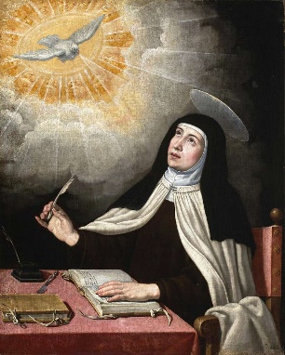
Born on March 28, 1515, in either Ávila or the nearby town of Gotarrendura, Saint Teresa of Ávila entered the world at a time of deep religious upheaval and renewal in the Church. She was born into a devout and noble Spanish family. Her father, Alonso Sánchez de Cepeda, was a successful merchant of strong Catholic conviction, and her mother, Beatriz de Ahumada, nurtured in Teresa a love for God from an early age. As a child, Teresa was captivated by the lives of the saints, and her heart burned with a desire for holiness so intense that at the age of seven she attempted to run away with her brother in hopes of dying a martyr for Christ.
The death of her mother when Teresa was fourteen left a lasting impression on her soul, leading her to entrust herself more fully to the Blessed Virgin Mary as her spiritual mother. Though she was sent to be educated by the Augustinian nuns, Teresa struggled, like many young people, with the pull of worldly interests. Yet beneath this struggle, God was preparing her for a deeper calling. At the age of twenty, after much interior conflict, she entered the Carmelite Convent of the Incarnation in Ávila, choosing a life dedicated to God despite her natural hesitations.
Her early years in religious life were marked by spiritual inconsistency. The convent itself had grown relaxed in discipline, and frequent social visits disrupted the silence necessary for deep prayer. Teresa later admitted that her heart was divided between God and the world. It was through suffering that God began to draw her closer. A serious illness left her bedridden for nearly a year and brought her to the brink of death. During this time, she turned more fully to prayer and spiritual reading. The writings of Saint Augustine of Hippo, especially his Confessions, helped her understand that even those who struggle can become saints.
After her recovery, Teresa experienced a profound and lasting conversion. She began to practice mental prayer with renewed dedication and gradually entered into deeper forms of union with God. Over time, she was granted extraordinary mystical experiences, including visions of Christ and moments of deep spiritual ecstasy. Among the most well-known of these was the Transverberation, in which she described an angel piercing her heart with a fiery spear, filling her with both intense pain and an overwhelming sweetness of divine love. These experiences, though questioned by some, were affirmed by wise spiritual directors and bore lasting fruit in her holiness.
As her relationship with God deepened, Teresa became increasingly aware of the need for reform within her religious community. She saw clearly that the Carmelite life had lost much of its original fervour and simplicity. Moved by a desire to restore a life of prayer, poverty, and silence, she set out to found a new kind of convent. In 1562, she established the Convent of St. Joseph in Ávila, embracing a stricter observance rooted in contemplation and total dependence on God. Though her efforts were initially met with suspicion and resistance, her trust in God never wavered.
Her reform soon spread beyond a single convent. With the help of Saint John of the Cross and other collaborators, Teresa helped establish the Discalced Carmelites, a renewed expression of Carmelite life committed to prayer and sacrifice. Over the course of twenty years, she travelled tirelessly across Spain, often in poor health and under difficult conditions, founding seventeen convents for women and supporting the establishment of monasteries for men.
This work was not without suffering. Teresa faced opposition from members of her own order, misunderstandings, and even formal restrictions on her ability to continue her foundations. At one point, she was ordered to cease her work and withdraw into one of her convents. Yet through humility, obedience, and perseverance, she continued to trust in God's providence. With the eventual support of Church authorities and the Spanish crown, her reform was allowed to continue and flourish.
Alongside her work as a reformer, Teresa became one of the Church's greatest spiritual writers. Her autobiography, The Life of Teresa of Jesus, recounts her journey of conversion and prayer. In The Way of Perfection, she offers practical guidance for those seeking to grow in holiness. Her masterpiece, The Interior Castle, describes the soul as a castle with many dwelling places, leading ultimately to union with God at its center. Through these works, she teaches that prayer is not reserved for a few, but is the path by which every soul can encounter the living God.
In her later years, Teresa continued her mission despite increasing physical weakness. While traveling to found yet another convent, she fell ill. In 1582, her earthly journey came to an end. Her final words reflected the deep love that had guided her entire life: "My Lord, it is time to move on... the hour that I have longed for has come." Because of the reform of the calendar that same year, her death is recorded as occurring on either October 4 or October 15, the latter now celebrated as her feast day.
Forty years after her death, she was canonized by Pope Gregory XV, and centuries later, in 1970, Pope Paul VI declared her a Doctor of the Church, making her the first woman to receive this title. This honour recognized not only her holiness, but the enduring wisdom of her teaching.
Saint Teresa of Ávila's life stands as a powerful witness to the transforming love of God. Through suffering, perseverance, and unwavering trust, she discovered that the deepest truth of the Christian life is found in prayer. Her words continue to echo through the centuries, inviting every soul into that same intimacy with God: let nothing disturb you, let nothing frighten you, all things are passing, God alone suffices.

SAINT CHARLES BORROMEO
(1538 - 1584)
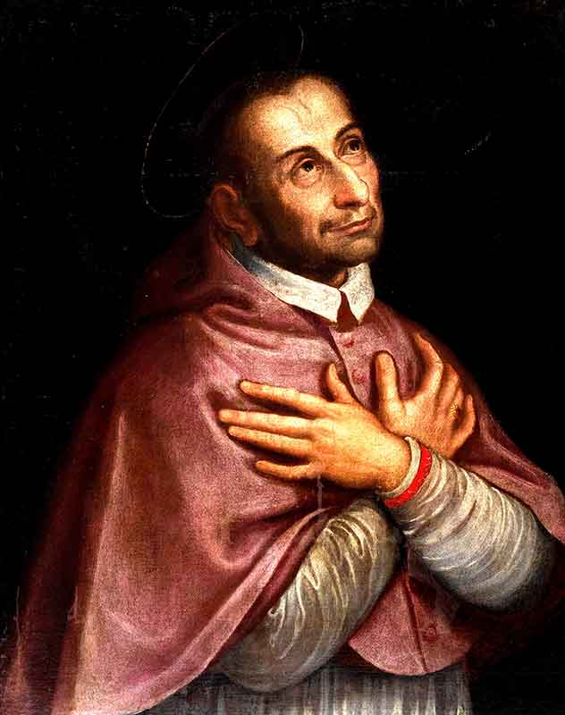
Saint Charles Borromeo was born on October 2, 1538 at the castle of Arona on Lake Maggiore near Milan. His father was the Count of Arona and his mother a member of the House of Medici. He was the third of six children born to the couple. At the age of 12, the young Count Charles Borromeo dedicated himself to a life of service to the Church. His uncle gave to him the family income from the Benedictine abbey of Saints Gratinian and Felinus. Even as a youth, his integrity was obvious. He was explicit in telling his father that he could only keep the money required for his education and to prepare him for service to the Church. All other funds belonged to the poor of the Church and were to be passed along to them. The young count suffered from a speech impediment that made him appear slow to those who did not know him. Despite this challenge, he performed well and impressed his teachers. He attended the University of Pavia and learned Latin. He was praised because he was hardworking and thorough. In 1554 his father passed away and although Charles was a teenager, responsibility for his household fell to him. Charles continued in his studies and earned a doctorate in canon and civil law. His responsibility for his household resulted in financial difficulties, and Charles earned a reputation for being short of funds. Life sped up for the young count after his uncle, Cardinal Giovanni Angelo Medici became Pope Pius IV on December 25, 1559. The new pope asked his nephew to come to Rome and appointed him as a cardinal-deacon. With the rank came the job of assisting and advising his uncle full-time. A month later, Pope Pius IV made his nephew a cardinal. With the new rank came even more duties including the government of the Papal States, the supervision of the Knights of Malta, the Franciscans, and the Carmelites. He was only 23 years old. The young Borromeo used his leadership role in the Vatican to promote learning and he established a literary academy. He wrote of some of the lessons and lectures in the book, Noctes Vaticanae. Borromeo was appointed administrator of the Archdiocese of Milan in 1560. Since he would become the ecclesiastical administrator of Milan, he decided that the Lord was calling him to the priesthood. In 1561, he founded a college at Pavia dedicated to St. Justina of Padua. In 1562 his brother died and his family urged him to leave the service of the church to preserve the family name. However, Borromeo refused. He became more insistent upon becoming a good bishop and in compelling others to lead exemplary lives of clerical service. Borromeo was ordained first to the order of deacon. Then, he was ordained to the holy priesthood on September 4, 1563. Then, he was ordained as a bishop on December 7, 1563. He became Archbishop of Milan in May 12, 1564.In 1566, Archbishop Borromeo’s benefactor and uncle, Pope Pius IV died. Borromeo had already developed a reputation as a young, idealistic reformer in Rome, and he continued that mission in Milan. Milan was the largest diocese in the Catholic Church at the time and corruption was rampant. The driving out of corruption was a critical matter during Borromeo’s time. The Protestant Reformation was spreading throughout northern Europe and constantly threatened to move south. The greatest defence against Protestant doctrinal errors and claims against the hierarchy of the Catholic Church was reform and the restoration of integrity to the Catholic Church. Archbishop Borromeo saw this clearly and he made this his mission. His strategy was to provide education to many clergy he saw as ignorant. He founded schools and seminaries and colleges for clergy. He also ended the selling of indulgences, a form of simony (Catholic Catechism #2120, and ordered monasteries to reform themselves. He made a lot of visits to various locations to inspect for himself. He ordered the simplification of church interiors, which was a major point of contention between some Catholics and Protestants. The complex and busy interiors were claimed to be a distraction from the worship of God. This danger was acknowledged during the Council of Trent which Archbishop Borromeo enforced. Even tombs belonging to his own relatives were cleared of inappropriate ornaments and embellishments. His work of cleaning up the Church also made him enemies. On one occasion a member of a small, decrepit order known as the “Humiliati” attempted to assassinate him with a pistol, but missed. Many of his subordinates and secular officials complained about the Archbishop throughout his career. However, the existence of these enemies only emboldened Borromeo and served as confirmation that his efforts to eradicate corruption were working. In 1576 a famine struck Milan followed by the plague, and many of the wealthy and powerful fled the city. Archbishop Borromeo remained. He used his own fortune to feed the starving people. When that money was spent, he took loans and went deep into debt. He may have fed 70,000 people per day. Eventually, the Archbishop convinced the local governor to return to his post and care for the people. In 1583, Archbishop Borromeo travelled to Switzerland and began work suppressing heresy there. Protestant heresies, along with witchcraft and sorcery had been widely reported. He founded the Collegium Helveticum to serve and educate Swiss Catholics. Eventually, the Archbishop’s life of work and toil began to take its toll. In 1584, he became ill with a fever. He returned to Milan where his conditioned worsened. When it became obvious, he would die, he was given his last Sacraments. He died on November 3, at the age of 46.He was beatified on May 12, 1602 by Pope Paul V. He was subsequently canonized by Pope Paul V on November 1, 1610.
St. Charles Borromeo’s feast day is celebrated on November 4. He is the patron of bishops, catechists, Lombardy, Italy, Monterey, California, cardinals, seminarians, spiritual leaders, and Sao Carlos in Brazil. St. Charles Borromeo has a beautiful shrine in the Milan Cathedral and is often depicted in art wearing his robes, barefoot, carrying the cross with a rope around his neck and his arm raised in blessing.

SAINT CATHERINE OF ALEXANDRIA
(287 - 305)
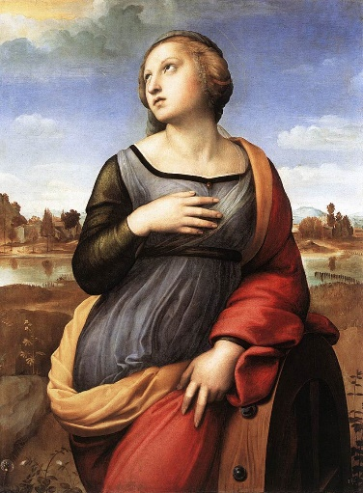
Saint Catherine of Alexandria is a canonized saint in the Catholic Church who, per Christian tradition, was martyred around 305 in Alexandria, Egypt. Of course, the Church of the first Millennium was undivided. She is also recognized as the Great Martyr and Saint by the Orthodox Church. There are no surviving primary sources attesting to her existence, but the fact that her memory, and the stories about her, have been kept alive - and handed down in the tradition - certainly confirm her existence, and her life of heroic virtue and holiness. The young saint was born around 287 in Alexandria, Egypt. At that time, Alexandria was one of the finest cities in the world, and a center of learning and culture as well as faith. Christian tradition states she was of noble birth, possibly a princess. As a member of the nobility, she was also educated and was an avid scholar. Around the age of fourteen, she experienced a moving vision of Mary and the infant Jesus, and she decided to become a Christian. Although she was a teenager, she was very intelligent and gifted. When the emperor Maxentius began persecuting Christians, Catherine visited him to denounce his cruelty. Rather than order her execution, Maxentius summoned fifty orators and philosophers to debate her. However, Catherine was moved by the power of the Holy Spirit and spoke eloquently in defence of her faith. Her words were so moving that several of the pagans converted to Christianity and were immediately executed. Unable to defeat her rhetorically or to intimidate her into giving up her belief, the emperor ordered her to be tortured and imprisoned. Catherine was arrested and scourged. Despite the torture, she did not abandon her faith. Word of her arrest and the power of her faith quickly spread and over 200 people visited her. According to some legends, the emperor's own wife, Valeria Maximilla was converted by Catherine. The emperor eventually executed his own wife over her conversion. However, this is not mentioned in the historical record and may be a legend. It is believed that Maximilla was alive and with her husband at the Battle of the Milvian Bridge in 312, seven years after the death of Catherina. Following her imprisonment, Maxentius made a final attempt to persuade the beautiful Catherine to abandon her faith by proposing marriage to her. This would have made her a powerful empress. Catherine refused, saying she was married to Jesus Christ and that her virginity was dedicated to him. The emperor angrily ordered her to be executed on a breaking wheel. The breaking wheel is an ancient form of torture where a person's limbs are threaded among the spokes and their bones are shattered by an executioner with a heavy rod. It is a brutal punishment that results in a slow and painful death, normally reserved for the worst criminals. When Catherine was presented before the wheel, she touched it and a miracle occurred that caused the wheel to shatter.
Unable to torture her to death, the emperor simply ordered her beheaded. One account claimed that angels took her body to Mt. Sinai. In the sixth century, the Emperor Justinian ordered a monastery established in her name. The monastery, Saint Catherine's, remains to this day and is one of the oldest in the world. Around the year 800, a legend spread that her body has been found with her hair still growing and a constant stream of oil coming from her body. Nothing exists to this day of her remains, and her very existence has been called into question. Despite these questions, and the possibility that her story may be confused with that of one or more other saints, she is still venerated in the Eastern Orthodox Church as a Martyr. Many Roman Catholics also venerate her to this day as one of the great virgin saints of the early Church. During the medieval period, St. Catherine was one of the most famous saints of the Church. She has was a popular subject in renaissance art and many paintings from the period are dedicated to her. Catherine is still a very popular Catholic name. The spiked wheel is a popular symbol often associated with St. Catherine. Her feast day is Nov. 25, and she is the patron of a great many professions and causes. Her patronage includes students, unmarried girls, apologists and many more as well as many places around the world.

SAINT JOHN OF THE CROSS
(287 – 305)
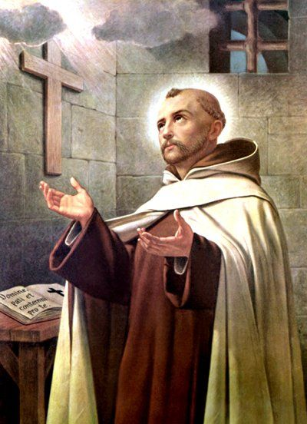
Saint John of the Cross was born Juan de Yepes y Alvarez, in Fontiveros, Avila, Spain in 1542. His father was employed by wealthy family members as an accountant, but they disowned him when he married a poor woman from the lower class. As a result of his family’s poverty, John’s family suffered greatly. His father died when he was three, and his older brother, Luis died two years after that, likely because of malnutrition. John’s mother eventually found work weaving which helped her to feed her family. As a child, John was sent to a boarding school for poor and orphaned children. He was given a religious education from a young age and chose to follow a religious path, even as a child. He served as an acolyte at an Augustinian monastery. As he grew older, he went to work in a hospital while attending a Jesuit school.In 1563, he was able to join the Carmelite Order and took the name, “John of St. Matthias.” He made vows the following year, and was sent to the university in Salamanca to study theology and philosophy. He became an expert in the Bible and dared to translate the Song of Songs into Spanish, an act which was controversial since the Church forbade the translation of the Bible from Latin –a measure to protect the original meanings in the scripture. John became a priest in 1567 and considered joining the Carthusian Order where monks lived cloistered in individual cells. He was attracted by the simple and quiet life. However, he encountered Theresa of Avila, a charismatic Carmelite nun. Theresa asked John to follow her. John was attracted by the strict routine followed by Theresa, a routine she hoped to reintroduce to her order, as well as her devotion to prayer and simplicity. Her followers went barefoot, and were therefore known as the discalced Carmelites. On Nov. 28, 1568, Theresa founded a new monastery. The same day, John changed his name again to John of the Cross. Within a couple years, John and his fellow friars, relocated to a larger site for their monastery. He remained at this location until 1572. In 1572, John travelled to Avila at the invitation of Theresa to become her confessor and spiritual guide. He remained in Avila until 1577. While there, he had a vision of Christ and made a drawing that remains to this day called, “Christ from Above.” The little drawing shows Christ on the cross, looking down on him from above. The image has been preserved for centuries. Around 1575, a rift within the Carmelite order began to grow and create controversy between various monastic houses. There was disagreement between the Discalced Carmelites and the ordinary Carmelites, over reform. The Discalced Carmelites sought to restore the original, strict routine and regimen that the order had when it was founded. In 1432, the strict rules of the order were “mitigated” relieving the Carmelites of some of their most strict rules. Some Carmelites, such as Theresa of Avila, felt this liberalization of their rule had interfered with their order and practice. Theresa, along with John, sought to restore the original rule. The Carmelites had been undergoing reform since 1566, under the direction of two Canonical Visitors from the Dominican Order, sent by the Vatican. The intervention of the Holy See as well as the political machinations of King Phillip II and his court, led to dramatic, even violent disagreement between the Carmelites. In late 1577, John was ordered to leave the monastery in Avila and to return to his original house. However, John’s work to reform the order had already been approved by the Papal Nuncio, who was a higher authority. Based on that, John chose to ignore the lower order and stay. On December 2, 1577, a group of Carmelites broke into John’s residence and kidnapped him. He was taken by force to the order’s main house in Toledo. He was brought before a court and placed on trial for disobedience. He was punished by imprisonment. A cell was made for him in the monastery that was so small he could barely lie on the floor. He was fed only bread and water, and occasional scraps of salt fish. Each week he was taken into public and lashed, then returned to his cell. His only luxuries were a prayer book and an oil lamp to read it by. To pass the time he wrote poems on paper that was smuggled to him by the friar charged with guarding his cell. John became known as a remarkable and influential poet, especially following his death. He has been cited as an influence to many poets, mystics, and artists, even Salvador Dali. After nine months, John managed to pry his cell door from its hinges and escape. He joined Teresa’s nuns in Toledo, and spent six weeks in the hospital to recover. In 1579, he was sent to the town of Baeza to be rector of a new college and to support the Discalced Carmelites in Andalusia. In 1580, Pope Gregory formally authorized the split between the Discalced Carmelites and the rest of the order. This ended the rift within the order. At that time, there were about 500 members in the order living in 22 houses. During the last few years of his life, John travelled and established new houses across Spain. In 1591, John became ill with a skin condition that resulted in an infection. He died on December 14, 1591, John of the Cross died. Shortly following his burial, there was a dispute over where he should be buried. The dispute was resolved by removing his legs and arms. Over the years, parts of his body were placed on display or buried across several places. Saint John of the Cross was beatified by Pope Clement X in 1675, and Canonized by Pope Benedict XIII in 1726. He is the patron of Contemplatives, mystics and Spanish poets and his feast day is celebrated on December 14

Bible Sharing No. 31

Peter’s Declaration about Jesus

Matthew 16:13-20
Reflections:

- In Holy Scripture, only those declared by a legitimate authority can speak as divinely inspired.
- Inspiration does not only come from God.
- The Church can act with certainty because of its infallibility and indestructibility.
- The Pope has jurisdiction over the whole Church.
- Those who are not united to the Pope, the Vicar of Christ, through faith and obedience cannot be saved.
- The Church has the power to forgive not only “eternal” pain but also temporal punishment by means of indulgences. (*)
- Sharing Exercise.

Self Questioning:

- Do you know that you can be inspired by God, by the devil or by nature itself?
- Can you recognise an inspiration coming from God, and one coming from the devil?
- Can you doubt that an inspiration for comfort, pleasure, fame and honours, may be coming from your own nature?
- Do you think that an inspiration coming from God and an inspiration coming from the devil, can be the same and not opposed to each other?
- Have you observed that people can only give from what they have?
- Can you imagine an inspiration coming from God; resulting in quarrels, troubles and teachings contrary to the teaching of his church?

Resolution:

We resolve to resist with conviction the inspirations of the devil and of our own nature, which will most certainly bring us trouble and unhappiness and to act according to the inspirations of God who is the only source of peace.

(*) 1471. The doctrine and practice of indulgences in the Church are closely linked to the effects of the sacrament of penance.
"An indulgence is a remission before God of the temporal punishment due to sins whose guilt has already been forgiven, which the faithful Christian who is duly disposed gains under certain prescribed conditions through the action of the church which, as the minister of redemption, dispenses and applies with authority the treasury of the satisfactions of Christ and the saints" (Indulgentarium Doctrina norm 1).
"An indulgence is partial or plenary according as it removes either part or all of the temporal punishment due to sin" (ibid. norm 2, norm 3).
Indulgences may be applied to the living or the dead.

Bible Sharing No. 223

The Ministry of the Apostles

1 Corinthians 4:1-21
Reflections:

- The validity of the sacraments depends on the faithful act of the minister.
- No one can be absolutely certain of being in the state of grace.
- Only God, who can see the interior of a person, can judge that person.
- A person has much reason to humble themselves.
- Those who seek their own satisfaction, can do no good either to themselves or to others.
- Appropriate means must be chosen according to the circumstances.
- Sharing Exercise.

Self Questioning:

- Do you know that the sacraments produce their effects through their proper administration?
- Do you think that a sacrament is valid if the minister has not the intention to do what the Church intends?
- Do you think that the Church can change any substantial part of the sacrament?
- Can you prove that the Church has always maintained that the sacraments are seven and that all were instituted by Christ?
- Do you know that each sacrament produces a special grace in the soul?
- Which of the sacraments produce the first grace and which ones produce the second grace?

Resolution:

We resolve to seriously prepare ourselves for the right reception of all the sacraments by a true spirit of repentance because without it no sin, whether light or grave can be forgiven.

Bible Sharing No. 390

GENTILES HEAR THE GOOD NEWS

Acts 10:24-48
Reflections:
- No one can despise another person, even if they are not of good standing, since we cannot say whether or not they have been chosen for the glory of heaven or not.
- All good deeds are pleasing to God, although not all procure merits in heaven.
- Not all religions are acceptable to God.
- Those who fear God are loved by God.
- God gives showers his graces, especially on those hearing the Word of God.
- The Sacraments of Baptism and Reconciliation must still be received even if one believes that they have made a perfect act of contrition.
- Self Sharing.

Self Questioning: (read note below before reading the following)
- Do you know that ordinarily, the Sacraments of Baptism and Reconciliation produce the first graces?

- Do you know that occasionally these two sacraments produce the second grace?

- Have you ever heard that an act of perfect love can make a person holy?

- Do you know the distinction between the first and second grace?

- If you are not sure of being in a sate of grace do you dare to receive those sacraments which produce the second grace?

- Are you able to mention instances when sacraments of the living, i.e. those which normally produce the second grace, produce the first one?

Resolution:
We resolve, to sanctify ourselves by the frequent reception of the Sacraments of Reconciliation and Holy Communion, by receiving them with a true hatred of all sons, even venial ones.
Note:
The term ‘First Grace’ refers to the sacraments of the dead. These are: Baptism and Reconciliation, and are called sacraments of the dead because their chief purpose is to give the supernatural life of sanctifying grace to souls spiritually dead through sin.

The term ‘Second Grace” refers to sacraments of the living. These include: Confirmation, Eucharist, Anointing of the Sick, Holy Orders and Marriage are called sacraments of the living, because those who receive them worthily are already living the life of grace.

Bible Sharing No. 450

Death of Samson

Judges 16:1-31
Reflections:

- To gain favours, nature makes use of persons who are dear to the heart.
- One cannot repent when it is a matter of love.
- Deceits can overcome, even a strong man.
- The spirit of nature gives up when requests are repeated.
- No one is certain the degree of harm which an enemy can inflict on a person.
- The threat of death is always present, even where one may feel safe.
- Exercises.
Self-Questioning
- Are you being prudent when you trust a person who has deceived once already?
- Do you believe, that because you are physically strong, you cannot be defeated?
- Do you see how a person who lives dangerously, will eventually fall into it?
- Are you able to trust yourself, knowing that deceits are hidden in what pleases your natural desires?
- Have you noted how quickly a person can turn against you when they see an opportunity more pleasing?
- Wouldn’t you begin to suspect something not right when you observe a certain curiosity in a person?

We resolve, like David, to pray to God, to deliver us from deceitful and wicked people, since we cannot know what lies within a person, and by using common sense, ensure we never place our trust where we detect any sign of deceit.

Bible Sharing No. 32

Self-denial and the Cross
Matthew 16:21-28

Reflections:

- A right Judgement is one, which is free of passion
- One imitates the devil when he acts according to the inclinations of his corrupt nature.
- It is necessary for the Christian to know about the life of Christ
- The spiritual and temporal lives are in opposition to each other.
- One has nothing dearer to him than his life.
- Happiness or punishment after death will not be of the same degree.
- Sharing Exercise

Self-Questioning:

- Do you know that a lover always gives preference to his beloved?
- Do you know that one who hates another will always try to degrade the person he hates?
- Have you ever observed the foundations on which man builds his judgements?
- Do you take advise carelessly without first studying the person from whom you are seeking advise, whether they are interested or not?
- Do you try to discover whether if your adviser is honest and learned?
- Do you understand the meaning of the saying, “Boast only after the fact”?

Resolution:

We resolve that in our serious undertakings we take the advice from people who fear God, who are skilled in matters under consideration, they have a genuine interest, and are people of prayer.

Bible Sharing No. 224

Sexual Immorality Defiles the Church

1 Corinthians 5:1-13
Reflections:

- The Christian must not only avoid sin but should also encourage others not to sin either.
- The Church has the power from Christ to cast out unfaithful members.
- The Church judges on the exterior but God sees also the interior.
- Every Society, which is seeking its own prosperity, should cast pout bad and dangerous members.
- No one can flee all temptations.
- Although many people consider themselves to be strong in virtue, they must not go into proximate occasions of sin.
- Sharing Exercise.

Self Questioning:

- Do you think that basket full of good fruit remains so if rotten fruit is placed in the same basket?
- Do you how much is human nature inclined to corruption?
- Do you know, by associating with the wicked, one may also become wicked?
- Doesn’t it make sense that if a member of the body is infected, the logical choice is to remove before it infects the rest of the body?
- What can one expect from keeping the company of the wicked, but sorrows, tears and unhappiness?
- Have you ever suffered from keeping the company of wicked people?

Resolution:

We resolve to avoid all intimacy with wicked people, being convinced of the harm which they can cause, both for this life and life to come.

Bible Sharing No. 391

PETER’S REPORT TO THE CHURCH AT JERUSALEM

Acts 11:1-18
Reflections:
- When a vision or other revelation from God is ignored, God repeats it again.
- Eternal salvation is through the Church whose visible head is the Pope, the Vicar of Jesus Christ.
- Facts cannot be denied.
- Ignorance does not judge correctly.
- All forms of scandal, whether by word, actions or other, is to be avoided.
- God grants the spirit of repentance to all those God wants to save.
- Self Sharing.

Self Questioning:
- Do you consider that a person who is bad to-day may become good tomorrow?

- Do you think you can question God’s unfathomable judgments?

- Have you ever thought that the gifts of God depend only on God’s mercy?

- If you are good now, can you be sure that you will persevere in this good life?

- Do you see in you the signs that you are one of those predestined for the eternal glory?

- Do you know that divine grace generally follows the good deeds one has performed towards ones neighbour?

Resolution:
We resolve, to ask God’s pardon for our past sins with a contrite heart, and in order to move God towards us, to practice charity towards our neighbour.

Bible Sharing No. 33

Jesus Cures a Boy with a Demon

Matthew 17:14-22

Reflections:

- Human nature predisposes its intended benefactor before asking a favour.
- The prayer of a humble heart always produces good effects.
- It is necessary for one to examine the cause of one’s defects if they wish to control them.
- Only those who possess true faith will progress in the spiritual life.
- No one is more powerful than a person who prays and practices self-denial.
- Separation is an enemy of love.
- Exercise

Self-Questioning:

- Do you treat a person from whom you want a favour, harshly or gently?
- Do you know that sin excites God’s anger?
- Do you know what is meant by the doctrine, “that we are made in the image of God”?
- Have you read in Scripture, how God fulfils the desires of those who fear God?
- Do you know that charity and humility dispose God in your favour?
- In your prayers, do you often remind God of your meekness in dealing with someone you dislike, so that you move God in your favour?

Resolution:

We resolve to pray to God with a pure heart which is free from any hatred to our neighbour so that we will be quickly answered by God in our petitions.

Bible Sharing No. 225

Lawsuits among Believers

1 Corinthians 6:1-20
Reflections:

- Peace is the mark of the true follower of Christ, that is, a Christian.
- The gravity of an evil act is known by the penalty imposed for it.
- Sins are forgiven through the merits of Jesus Christ.
- The resurrection of the body is performed not through natural means, but supernatural power.
- One is generally known by what they love – if they love the world, they are worldly, if they love God, they are Godly.
- No has any permission to do what is wrong.
- Sharing Exercise.

Self Questioning:

- Do you observe how much do people claim their own rights?
- Do you think that it is a sin to claim your own rights by fair means?
- Do you realise the danger by breaking brotherly love through hatred when seeking your own rights?
- How can you defend your rights against your neighbour, when God forgoes his right against you for your sins?
- Have you ever weighed Our Lord’s words, when he said, that you will be measured with the same scale that you measured others?
- Can anyone truly say that they have never sinned?

Resolution:

We resolve that in injuries we receive from others, we remember that we have broken God’s rights by our sins, and thus be ready to, not only forgive our enemy, but also to love them and pray for them as instructed by Our Lord.


Bible Sharing No. 79


The Birth of Jesus

The Gospel of St Luke – 2:1-20

Reflections:
- The commands of those in authority need to be obeyed.
- The first surroundings of the Son of God, who came to bring peace to all people, indicate poverty and sufferings.
- God firmly confirms any message from himself.
- Whoever receives Christ, will in turn receive true joy.
- No single act of God can be called small.
- Those who ardently love God, have to live in a state of continual resignation.
- Sharing Exercises.
Self-Questioning:
- Can you distinguish the difference between obeying and doing your own will?
- Are not your suspicions aroused, when you decide to do your own will?
- Do you know the spiritual and temporal values of obedience?
- When you obey some instruction, have you ever examined what made you do so?
- Have you ever noted the cause of Christ’s birth and death?
- How can one not esteem the virtue of obedience, when one learns that its effects are true peace and rewards?
Resolution:
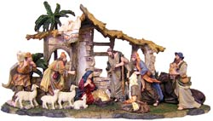
We resolve, to continue always and without complaint, any directions and rules that come from those whose only desire is our good in the Lord.

