The Word of God was made flesh

Society of Christian Doctrine

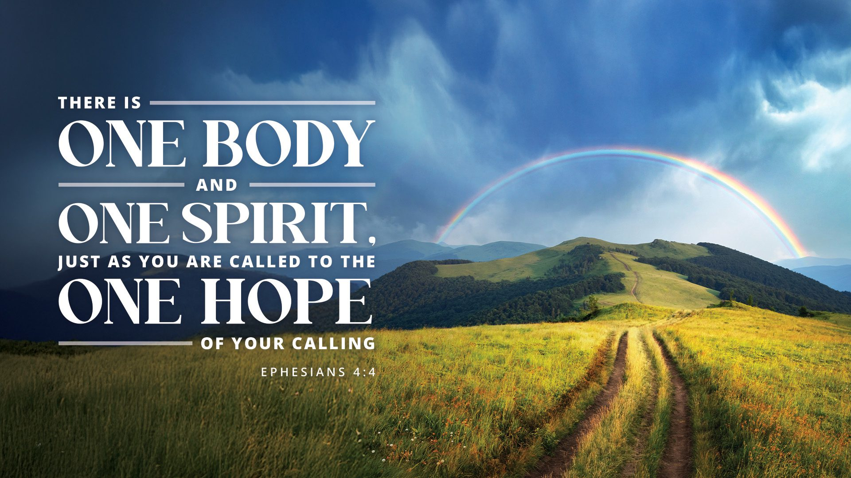

44th Year 2008

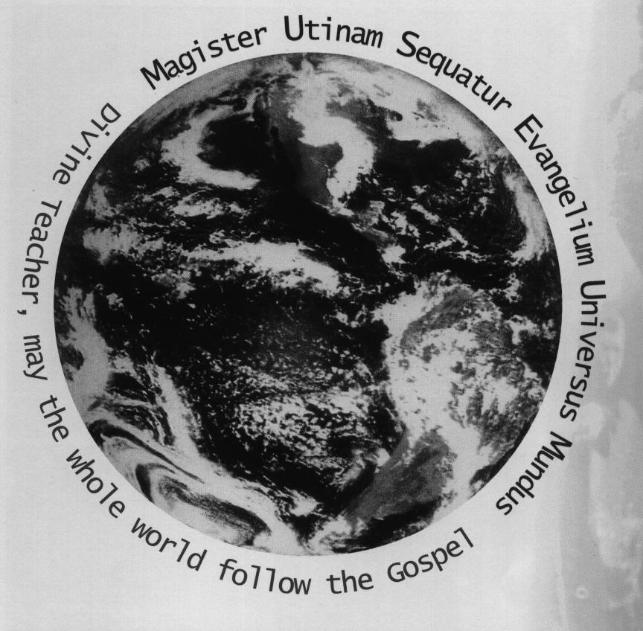

Assignment

Programme

February - March

2026

CONTENTS

SYLLABUS SUGGESTED TIMELINE 2
2008 SYLLABUS AT A GLANCE 3

TALKS 4
SPECIAL PROTECTORS 4
WATCH LITANY INTENTIONS 4
SPECIAL PROGRAMMES 4
COMMEMORATIONS 4

THOUGHT OF THE MONTH 5

NOTES 5

y all that
The Word of God was made flesh

PRECA COMMUNITY
(Society of Christian Doctrine)

62nd Year 2026

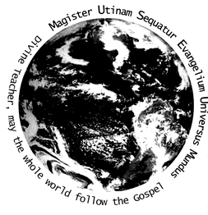

For the 2026 Week of Prayer for Christian Unity, Pope Leo XIV emphasized the theme, “There is one body and one Spirit, just as you were called to the one hope of your calling” (Ephesians 4:4), calling for visible unity. Under his motto In Illo uno unum ("In the One, we are one"), he stresses that this unity is a divine imperative, not just an ideal, bridging diverse traditions in Christ.
Key aspects of Pope Leo XIV's focus on this theme include:
- Source of Theme: The theme is taken from St. Paul's Letter to the Ephesians and was used for the Week of Prayer for Christian Unity (January 18-25, 2026).
- Vision for Unity: Pope Leo XIV argues that Christian unity is a "gift from on high" rather than just human effort, encouraging churches to move beyond internal divisions.
- Episcopal Motto: His motto, In Illo uno unum, is rooted in St. Augustine's teaching that although Christians are many, they are one in Christ.
- Ecumenical Action: The Pope emphasized this message during ecumenical vespers, highlighting the need for "a communion which does not imply absorption or domination, but rather an exchange of the gifts".
- Context: The 2026 materials were prepared in collaboration with the Armenian Apostolic Church, with the Pope highlighting the Armenian Christian witness and encouraging dialogue in the face of suffering

CONTENTS

SYLLABUS 4
TALKS 5
SPECIAL PROTECTORS 5
WATCH LITANY INTENTIONS 5
SPECIAL PROGRAMMES 5
COMMEMORATIONS 5

THOUGHT OF THE MONTH 5

GENERAL NOTES 6

ANNIVERSARIES 6
WEEKLY ASSIGNMENT 6
CODES 6
PROGRAMME FOR THE MONTH OF FEBRUARY 7
PROGRAMME FOR THE MONTH OF MARCH 8

BIOGRAPHY OF ST. BRIGID OF IRELAND (Sunday February 01st) 9-10
BIOGRAPHY OF ST. DAVID OF WALES (Sunday March 01st) 11-12
BIOGRAPHY OF ST CUTHBERT (Friday March 20^{th)} 13-14

BIBLE SHARING NO. 23 (Matthew 13:1-23) (Friday February 06th) 15
BIBLE SHARING NO. 216 (Romans 15:15-33) (Friday February 13th) 16
BIBLE SHARING NO. 391 (Acts 11:1-18) (Friday February 20th) 17

BIBLE SHARING NO. 24 (Matthew 13:1-23) (Friday February 06th) 18
BIBLE SHARING NO. 217 (Romans 8:19-39) (Friday March 13th) 19
BIBLE SHARING NO. 392 (Acts 8:1-25) (Friday March 20th ) 20

SPIRITUAL EXAMINE CHAPTERS FOR:
FEBRUARY – Fortitude MARCH – Temperance

SYLLABUS
February – March - 2026

IMPORTANT DOCUMENTS & PROCEDURES

February – March On the 7th, 17th and 27th 0f the month, any of the following can be studies: 1. Rule of Life
2. For the Seed to bear Fruit
3. The Dimensions of an SDC Centre
4. Urgings of the Heart

February – March Prayer and Liturgy
The General Instruction of the Roman Missal cont..
The Structure of the Mass, Different Elements of the Mass Para.55-60

February – March Dogmatic Studies

The Real Presence in the Eucharist

February – March Moral Studies
The Life and Dignity of the Human Person

February – March Spirituality

Prayer and Contemplation

February – March Voice of the Beloved
The Parables of Jesus – (1) The Wedding Feast (Matthew 22:1-14; Luke 14:16-24) (2) The Ten Virgins (Matthew 25:1-13

February – March Apostolic Studies
The Letter of Paul to the Church in Rome

February – March Church History
Study of Vatican 1 cont…

February – March Old Testament Studies
The Book of Maccabees cont.. or Book of Choice.

February – March From the Encyclicals and other Church Documents
POPE LEO XIV APOSTOLIC EXHORTATION (DILEXI TE) TO ALL CHRISTIANS ON THE LOVE FOR THE POOR

February – March From the Founders Writings
Any writings from the founder.

SPIRITUAL EXAMINE CHAPTERS FOR:
FEBRUARY – Fortitude (Courge) MARCH – Temperance

THE DIVINE ATTRIBUTES
(Refer: The Watch pgs. 94-98)

Monday – Eternity | Tuesday - Immensity | Wednesday – Immutability
Thursday – Wisdom | Friday – Justice | Saturday – Mercy

Sunday - Omnipotence

Talks

February 18th Ash Wednesday – Beginning of Lent
March 15th St Patrick, Bishop – Patron of Australia
March 19th St Joseph – Spouse of Mary

Special Protectors

The Month of February All Holy Martyrs
The Month of March The Holy Family

Watch Litany Intentions

The Month of February That by God’s power, may the SDC have an increase in young people.

The Month of March May all who are associated with the SDC persevere in their vocation.

Special Programmes

February 18th Ash Wednesday - Lent
March 17th St Patrick, bishop
March 19th St Joseph, Husband of Mary

Commemorations

February 1st St Brigid of Ireland
March 1st St David of Wales
March 20th St Cuthbert

Thought of the Month

The Month of February Eternity
The Month of March Suffering Precedes Joy.

General Notes

1. February 02nd , March 03rd (Please refer to exercise on page 100 in the members Watch)
2. February 2nd Presentation of Jesus in the Temple (15 Decades of the Rosary)
3. February 2nd SDC Foundation (2/2/1907) (information only)
4. February 12th Birthday of the Founder, St George Preca (12-02-1880)
5. February 18th Beginning of Lent – Ash Wednesday (During the season of Lent, after the Union on Sunday’s, the members are to read the Examine from the Watch pg. 125, combined)
6. March 09th Labour Day Public Holiday (Melbourne Centres)
7. March 17th St Patrick
8. March 19th St Joseph Spouse of Mary
9. March 25th The Annunciation of the Lord (15 Decades)

Anniversaries

God of power and mercy, you have made death itself the gateway to eternal life. Look with love on our dying brothers/sisters, and make them one with Your Son in His suffering and death, that, sealed with the blood of Christ, they may come before you free from sin. Amen.

- February 08th Joseph Zammit (08-02-2008)
- February 08th Maurice Mifsud (08-02-2010)
- February 16th Henry Brincat (16-02-2008)
- March 04th Vincent Xerri (04-03-1996)
- March 12th Eugene Borg (12-03-1967)
- March 15th Dr. Joseph Abela (15-03-1991)
- March 26th Stan Drozdow (26-03-2018)

Weekly Assignment Subjects

(Recommended only)

Monday:- Dogmatic Studies (D.S.) and Voice of the Beloved (V.B.)
Tuesday:- Spiritual Formation (S.F.) and Apostolic Studies (A.S.)
Wednesday:- Pedagogy (Lesson Preparation techniques)
Thursday:- Moral Studies (M.S.) and Old Testament (O.T.)
Friday:- Church History (C.H.)
Saturday:- Pedagogy, Prayer and Liturgy
Sunday:- (am) Bible Sharing and (pm) Union. (In States where this occurs)

Assignment Subject Codes
See Above

Programme for the Month of

FEBRUARY 2026

Thought of the Month: Eternity

Watch Litany Intentions: That by God’s power, May the SDC have an increase in young

people.

ASSIGNMENT ITEM | DESCRIPTION | DATE (*)
LITURGIES | NIL
TALKS | NIL
SPIRITUAL EXAMINE TOPIC | Virtue of Fortitude | (**)
COMMEMORATIONS | St Brigid of Ireland | 01/02/2024
CANON LAW | Paragraphs: 756 - 761 | (**)
SPIRITUAL DIRECTORY | Directives 205 - 211 | (**)
FROM THE FOUNDER’S WRITINGS | Discipleship – Topic 12 (E-H) | (**)
UNION READINGS  OR OTHER | Theme: Obedience  Epistle: - Hebrews 5:5-10  Gospel: - John 12:44-50  Great Book: Page 30  Theme: Courage in God’s Service  Epistle: - 2 Corinthians 4:7-18  Gospel: - Luke 12:1-12  Great Book: Page 1  Theme: The Preciousness of the Human Soul  Epistle: - 1 Peter 1:13-21  Gospel: - Luke 9:18-27  Great Book: Page 4 | Sunday 8th  Sunday 15th  Sunday 22nd
BIBLE SHARING  (Note: For those Centres that do not meet in the morning, the BS can be done anytime during the week) | No. 23 (Matthew 13:1-23)  No. 216 (Romans 5:15-33)  No. 391 (Acts 11:1-18) | Friday 6th  Friday 13^{h}  Friday 20th
CHORAL WATCH | NIL THIS MONTH
ANNIVERSARIES | Joseph Zammit - NSW/Malta (08/02/2008)  Maurice Mifsud – Tasmania /Malta (08/02/2010)  Henry Brincat – Sth Australia (06/02/2018) | 8th  8th  16th

(*) Date shown is only recommended. This item may be done anytime during the month
(**) indicates can be done anytime during the month.

Note: for the regular subject matters, the local superior may choose the day and allocated time during the month.

Programme for the Month of

MARCH 2026

Thought of the Month: Suffering Precedes Joy

Watch Litany Intentions: May all who are associated with the SDC persevere in their

Vocation.

ASSIGNMENT ITEM | DESCRIPTION | DATE (*)
LITURGIES | Ash Wednesday | 18th March
TALKS | Ash Wednesday  St. Patrick, Bishop  St Joseph, Husband of Mary | 18th March  17th March  19th March
SPIRITUAL EXAMINE TOPIC | Virtue of Fortitude | (**)
COMMEMORATIONS | St Cuthbert | 01st March
CANON LAW | Paragraphs: 762 - 772 | (**)
SPIRITUAL DIRECTORY | Directives 212 - 217 | (**)
FROM THE FOUNDER’S WRITINGS | Discipleship Topic 13 (A– D) | (**)
UNION READINGS | Theme: The Preciousness of the Human Soul  Epistle: - 1 Peter 1:13-21  Gospel: - Luke 9:18-27  Great Book: Page 4  Theme: The Horror of Sin  Epistle: Romans 7:14-25  Gospel: Matthew 5:27-30  Great Book: Page 5  Theme: Death  Epistle: 2 Corinthians 5:1-10  Gospel: Mark 13: 33-37  Great Book: 6 | Sunday 01st March  Sunday 8th March  Sunday 15th March
BIBLE SHARING  (Note: For those Centres that do not meet in the morning, the BS can be done anytime during the week) | No. 24 (Matthew 13:24-43)  No. 217 (Romans 16:1-27)  No. 392 (Acts 11:19-30) | Friday 6th  Friday 13th  Friday 20th
CHORAL WATCH | Monday Episodes  Eloquia (15-20 min); Choral Watch –  Part 1 – (6.00am-12.00 noon)  (pm) Part 2 (2.00pm-7.00pm) to include Episodes from St Elijah | 28th & 29th
ANNIVERSARIES | Vincent Xerri – Melbourne (02/03/96)  Eugene Borg - Malta (12/03/1967)  Dr. Joseph Abela – Melbourne (15/03/1991)  Stan Drozdow – Melbourne (26/03/2018 | 04th  12th  15th  26th

(*) Date shown is only recommended. This item may be done anytime during the month
(**) indicates can be done anytime during the month.

ST BRIGID OF IRELAND
(451 – 525)
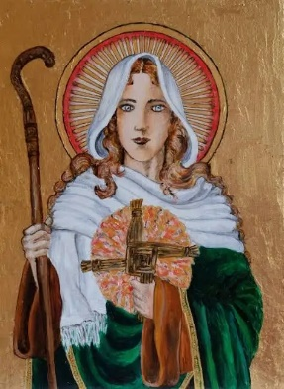
Saint Brigid was born Brigit, and shares a name with a Celtic goddess from whom many legends and folk customs are associated.
There is much debate over her birthparents, but it is widely believed her mother was Brocca, a Christian baptized by Saint Patrick, and her father was Dubthach, a Leinster chieftain. Brocca was a slave, therefore Brigid was born into slavery.
When Dubthach's wife discovered Brocca was pregnant, she was sold to a Druid landowner. It is not clear if Brocca was unable to produce milk or was not present to care for Brigid, but legend states Brigid vomited any food the druid attempted to feed her, as he was impure, so a white cow with red ears sustained her instead.
Many stories of Brigid's purity followed her childhood. She was unable to keep from feeding the poor and healing them.
One story says Brigid once gave her mother's entire store of butter, that was later replenished after Brigid prayed.
When she was about ten-years-old, Brigid was returned to her father's home, as he was her legal master. Her charity did not end when she left her mother, and she donated his possessions to anyone who asked.
Eventually, Dubthach became tired of her charitably nature and took her to the king of Leinster, with the intention of selling her. As he spoke to the king, Brigid gave his jewelled sword to a beggar so he could barter it for food for his family. When the king, who was a Christian, saw this, he recognized her heart and convinced Dubthach to grant her freedom by saying, "Her merit before God is greater than ours."
After being freed, Brigid returned to the Druid and her mother, who was in charge of the Druid's dairy. Brigid took over and often gave away milk, but the dairy prospered despite the charitable practice, and the Druid eventually freed Brocca.
Brigid then returned to Dubthach, who had arranged for her to marry a bard. She refused and made a vow to always be chaste.
Legend has it Brigid prayed that her beauty be taken so no one would want to marry her, and the prayer was granted. It was not until after she made her final vows that her beauty was restored.
Another tale says that when Saint Patrick heard her final vows, he accidentally used the form for ordaining priests. When the error was brought to his attention, he simply replied, "So be it, my son, she is destined for great things."
Little is known about Saint Brigid's life after she entered the Church, but in 40 she founded a monastery in Kildare, called the Church of the Oak. It was built above a pagan shrine to the Celtic goddess Brigid, which was beneath a large oak tree.
Brigid and seven friends organized communal consecrated religious life for women in Ireland and she founded two monastic institutions, one for men and one for women. Brigid invited a hermit called Conleth to help her in Kildare as a spiritual pastor.
Her biographer reported that Brigid chose Saint Conleth "to govern the church along with herself."
She later founded a school of art that included metalwork and illumination, which Conleth led as well. It was at this school that the Book of Kildare, which the Gerald of Wales praised as "the work of angelic, and not human skill," was beautifully illuminated, but was lost three centuries ago.
There is evidence that Brigid was a good friend of Saint Patrick's and that the Trias Thaumaturga claimed, "Between St. Patrick and Brigid, the pillars of the Irish people, there was so great a friendship of charity that they had but one heart and one mind. Through him and through her Christ performed many great works."
Saint Brigid helped many people in her lifetime, but on February 1 525, she passed away of natural causes. Her body was initially kept to the right of the high altar of Kildare Cathedral, with a tomb "adorned with gems and precious stones and crowns of gold and silver," but in 878, during the Scandinavian raids, her relics were moved to the tomb of Patrick and Columba.
In 1185, John de Courcy had her remains relocated in Down Cathedral. Today, Saint Brigid's skull can be found in the Church of St. John the Baptist in Lumiar, Portugal. The tomb in which it is kept bears the inscription, "Here in these three tombs lie the three Irish knights who brought the head of St. Brigid, Virgin, a native of Ireland, whose relic is preserved in this chapel. In memory of which, the officials of the Altar of the same Saint caused this to be done in January AD 1283."
A portion of the skull was relocated to St. Bridget's Church and another was sent to the Bishop of Lisbon in St. Brigid's church in Killester.
Saint Brigid's likeness is often depicted holding a reed cross, a crozier, or a lamp.

SAINT DAVID OF WALES
(520 – 600)
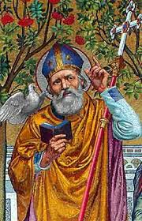
March 1st is St. Davids Day, the National Day of Wales and has been celebrated as such since the 12th Century. Today the celebrations usually involve the singing of traditional songs followed by a Te Bach, a tea with bara brith (famous welsh fruited bread) and teisen bach (welsh cake). Young girls are encouraged to wear national costume and leeks or daffodils are worn, being the national symbols of Wales.
So who was St. David (or Dewi Sant in Welsh)? Actually not too much is known about St David except from a biography written around 1090 by Rhygyfarch, son of the Bishop of St. Davids.
David was reputedly born on a cliff top near Capel Non (Non’s chapel) on the South-West Wales coast during a fierce storm. Both his parents were descended from Welsh royalty. He was the son of Sandde, Prince of Powys, and Non, daughter of a chieftain of Menevia (now the little cathedral town of St David’s). The site of Davids birth is marked by the ruins of a tiny ancient chapel close to a holy well and the more recent 18th century chapel dedicated to his mother Non can still be seen near St. David’s Cathedral.
St. Davids Cathedral
In medieval times it was believed that St David was the nephew of King Arthur. Legend has it that the patron saint of Ireland, St. Patrick – also said to have been born near the present day city of St. Davids – foresaw the birth of David in approximately 520AD.
The young David grew up to be a priest, being educated at the monastery of Hen Fynyw under the tutorage of St. Paulinus. According to legend David performed several miracles during his life including restoring Paulinus’ sight. It is also said that during a battle against the Saxons, David advised his soldiers to wear leeks in their hats so that they could easily be distinguished from their enemies, which is why the leek is one of the emblems of Wales!
A vegetarian who ate only bread, herbs and vegetables and who drank only water, David became known as Aquaticus or Dewi Ddyfrwr (the water drinker) in Welsh. Sometimes, as a self-imposed penance, he would stand up to his neck in a lake of cold water, reciting Scripture! It is also said that milestones during his life were marked by the appearance of springs of water.
Becoming a missionary David travelled throughout Wales and Britain and even made a pilgrimage to Jerusalem where he was consecrated bishop. He founded 12 monasteries including Glastonbury and one at Minevia (St. Davids) which he made his bishops seat. He was named Archbishop of Wales at the Synod of Brevi (Llandewi Brefi), Cardiganshire in 550.
Monastery life was very strict, the brothers having to work very hard, cultivating the land and pulling the plough. Many crafts were followed – beekeeping, in particular, was very important. The monks had to keep themselves fed as well as provide food and lodging for travellers. They also looked after the poor.
St David died on 1 March 589A.D., at Minevia, allegedly over 100 years old. His remains were buried in a shrine in the 6th century cathedral which was ransacked in the 11th century by Viking invaders, who plundered the site and murdered two Welsh bishops.
St. David – Patron Saint of Wales
After his death, his influence spread far and wide, first through Britain and then by sea to Cornwall and Brittany. In 1120, Pope Callactus II canonised David as a Saint. Following this he was declared Patron Saint of Wales. Such was Davids influence that many pilgrimages were made to St. David’s, and the Pope decreed that two pilgrimages made to St. Davids equalled one to Rome while three were worth one to Jerusalem. Fifty churches in South Wales alone bear his name.
It is not certain how much of the history of St. David is fact and how much is mere speculation. However in 1996 bones were found in St. David’s Cathedral which, it is claimed, could be those of Dewi himself. Perhaps these bones can tell us more about St David: priest, bishop and patron saint of Wales.

SAINT CUTHBERT OF LINDISFARNE
(635 – 687)

St Cuthbert, as depicted in the church by glazier Harry Clarke. Born not far from Melrose in about 635AD, Cuthbert’s early years were filled with events pointing to his future as the greatest of the Anglo-Saxon saints. After seeing a vision of the soul of Saint Aidan being escorted to heaven by angels, Cuthbert decided to become a monk and entered Melrose Abbey. Sometime later, he went to Ripon and became guest-master there, with the special duty of welcoming and tending to strangers and other visitors. When Saint Wilfrid was made abbot of Ripon, Cuthbert returned to Melrose and, surviving an outbreak of plague, became Prior. After several years, Cuthbert was appointed as Prior of Lindisfarne (pictured above), a much larger community. As Prior, Cuthbert governed gently and faithfully but yearned to be alone with God and so was given permission to go to the Inner Farne, a few miles off-shore from Lindisfarne, to devote himself to prayer and contemplation. However, his holiness continued to be spoken of throughout the country and, following a meeting of bishops, King Ecgfrith persuaded a reluctant Cuthbert to leave his island retreat and to become Bishop of Lindisfarne. He fulfilled his ministry with great tenderness and energy, but the Farnes called to him again.
Durham Cathedral, built as St Cuthbert’s shrine
After two years as Bishop, Cuthbert resigned and retired into solitude, devoting himself to prayer and preparing himself for his own death. When death came, on 20th March 687AD, he was buried in the monastery at Lindisfarne, where he remained for nearly 200 years before the monks fled from the invading Vikings, taking Cuthbert’s body with them on their journey. After spending over 100 years at Chester-le-Street, the monks eventually brought the body of Cuthbert to Durham, where it remains to this day in the Cathedral built as his shrine.

The deeds of St Cuthbert
Cuthbert was so skilful a speaker, and had such a light in his angelic face, and such a love for proclaiming his message, that none presumed to hide his inmost secrets, but all openly confessed their wrong-doing… He used mainly to visit and preach in the villages that lay far distant among high and inaccessible mountains, which others feared to visit and whose barbarity and squalor daunted other teachers. (Bede’s Ecclesiastical History)

The words of St Cuthbert
Speaking to his companions just before his death: Live in mutual harmony with all other servants of Christ. Do not despise those faithful who come to you seeking hospitality. Receive them, put them up, and set them on their way with kindness, treating them as one of yourselves. Do not ever think yourselves better than your companions who share the same faith and follow the monastic life.

Bible Sharing No. 23

The Sower

Matthew 13:1-23
Reflections:

- Listening to the Word of God, is the beginning of merit and glory.
- There are many dangers to the spiritual life.
- A clever mind is of no use unless it is developed and educated.
- Only a steadfastness in virtue make a truly spiritual person.
- Every believer acts according to the strength of their faith.
- Riches are only a bed of thorns for those who rest their mind on them.
- Exercise

Self-Questioning:

- Did you ever examine the dangers your inclinations bring to the soul?
- Which of your natural inclinations tempt you most; riches, honours or sensuality?
- Have you ever experienced the strength of your natural inclinations?
- Do you know that these inclinations are like a wild beast: the more they are satisfied, the wilder they become?
- Have you ever meditated on the emptiness of their satisfaction?
- Do you know that we acquire virtues by going against our natural inclinations?

Resolution:

We resolve that, moved by our hope of eternal salvation, we will practice moderation in all our natural desires, by continually going against our inclinations, and to seriously avoid every occasion of sin.

Bible Sharing No. 216

Paul’s Plan to Visit Rome

Romans 15:15-33
Reflections:

- One’s words are a witness to those who have to deal with that person.
- Offering your assistance to others, helps one get what they want.
- Those who are colleagues are preferred when goods are being distributed.
- An excess of goods can be either be for the good or bring about evil.
- God will always help those in whatever vocation they have been called.
- Some events will take place due to the prayers of the righteous.
- Sharing Exercise.

Self-Questioning:

- Is it possible that God does not give help to one who has been called to do some righteous work?
- Do you think that any work for which God was not the author will ever succeed?
- Do you know what the consequences are for work approved by God and work approved by man?
- Do you understand the meaning of Psalm 127, “Unless the Lord builds the house the builders labour in vain”.
- Is there any reason why you should get upset after performing some work which resulted in complete failure?
- Do you think that God will not reward you for some work you performed with a right intention, but which resulted in a complete failure?

Resolution:

We resolve, never to be sad if we want to do something and we only see opposition and obstacles against it, convinced that if this is ordained by God’s wisdom every opposition and obstacle will turn in its favour, and if this work is moved by self-will, even if there will be many in favour, it will eventually collapse.

Bible Sharing No. 391

PETER’S REPORT TO THE CHURCH AT JERUSALEM

Acts 11:1-18
Reflections:
- When a vision or other revelation from God is ignored, God repeats it again.
- Eternal salvation is through the Church whose visible head is the Pope, the Vicar of Jesus Christ.
- Facts cannot be denied.
- Ignorance does not judge correctly.
- All forms of scandal, whether by word, actions or other, is to be avoided.
- God grants the spirit of repentance to all those God wants to save.
- Self Sharing.

Self Questioning:
- Do you consider that a person who is bad to-day may become good tomorrow?

- Do you think you can question God’s unfathomable judgments?

- Have you ever thought that the gifts of God depend only on God’s mercy?

- If you are good now, can you be sure that you will persevere in this good life?

- Do you see in you the signs that you are one of those predestined for the eternal glory?

- Do you know that divine grace generally follows the good deeds one has performed towards one’s neighbour?

Resolution:
We resolve, to ask God’s pardon for our past sins with a contrite heart, and in order to move God towards us, to practice charity towards our neighbour.

Bible Sharing No. 24

The Parable of Weeds among the Wheat

Matthew 13:24 - 43
Reflections:

- It is necessary to take advice even in that which seems to be obvious.
- The devil will always avoid a person who puts up a degree of resistance to its suggestions (temptations).
- Evil usually comes from those who hate you rather than those who love you.
- An un-tested virtue does not gain any value or receive a crown of glory.
- An inexperienced spiritual director can be the cause of loss of souls.
- Christ’s teaching in his Church is an infallible rule of salvation.
- Exercise

Self-Questioning:

- Do you act according to your whims or after you take advice?
- Do you take advice from anybody, or from a person who has the necessary qualifications?
- Apart from good example, do you seek prudence and knowledge in a spiritual director?
- Do you know that after each action, it is usually followed by peace or regret?
- Do you like to listen to the teaching of Christ and the wisdom of the proverbs?
- Do you have recourse to prayer which is the greatest act of prudence?

Resolution:

We resolve to take advice, remember past experiences, examine present circumstances and consider possible results before every action even if it appears to be good, and to accompany every action by prayer so that we can be sure not to be sorry afterwards.

Bible Sharing No. 217

Personal Greetings

Romans 16:1-27
Reflections:

- A recommendation should be based on good works.
- Payment is according to the person who has received favours.
- Those who say speak against an article of faith should not be treated indifferently.
- What is pleasing can be the beginning of deceits.
- A person who speaks good and evil is to be avoided.
- The Innocent should be protected against evil people.
- Sharing Exercise.

Self-Questioning:

- Do you know that those who intend to perform an evil act will usually wait until those in leadership are absent?
- Isn’t wise to warn other shepherds when you notice that a ‘wolf is present’?
- Do you know that hypocrisy is an evil that usually traps those who are innocent and who do not know evil?
- Do you think you can overcome evil without prayer, when we read that David prayed to God to deliver him from wicked people?
- Do you continually monitor your state of grace?
- Isn’t it prudent to warn those who are innocent of heart not to seek advice from anybody, as many could be wolves in sheep’s clothing, and take advantage of the innocent?

Resolution:

We resolve that with a spirit of love, instruct the young to be careful with whom they associate with, especially if they are offered gifts, as it may be a way to deceive them.

Bible Sharing No. 392

THE CHURCH IN ANTIOCH

Acts 11:19-30
Reflections:
- Where there is God there is also true prosperity.
- A good person rejoices when they see good in others.
- Help increases power, and it is therefore to be sought.
- Temptations for those seeking holiness are trials of their virtues.
- Events prove the truth of a prophecy.
- No one is to be trusted unless they are well known.
- Self Sharing.

Self Questioning:
- If your neighbour is not in need, how can you practice the virtue of charity?

- If it were not for temptations, can you practice the virtue of patience which is the way that leads to eternal life?

- Do you know that a virtue without trials is no virtue at all?

- Do you know that many holy people rid themselves of many imperfections when they were stricken by some illness?

- Do you see how mishaps show the vanity of this life?

- How deep is your humility if you cannot bear some contempt from those around you?

Resolution:
We resolve that in any adversity, we bring to mind the words of the prophet Job and say with him “The Lord gave and the Lord has taken away; blessed be the name of the Lord”, convinced that these temporal adversities are sent to us by God for our greater good.

